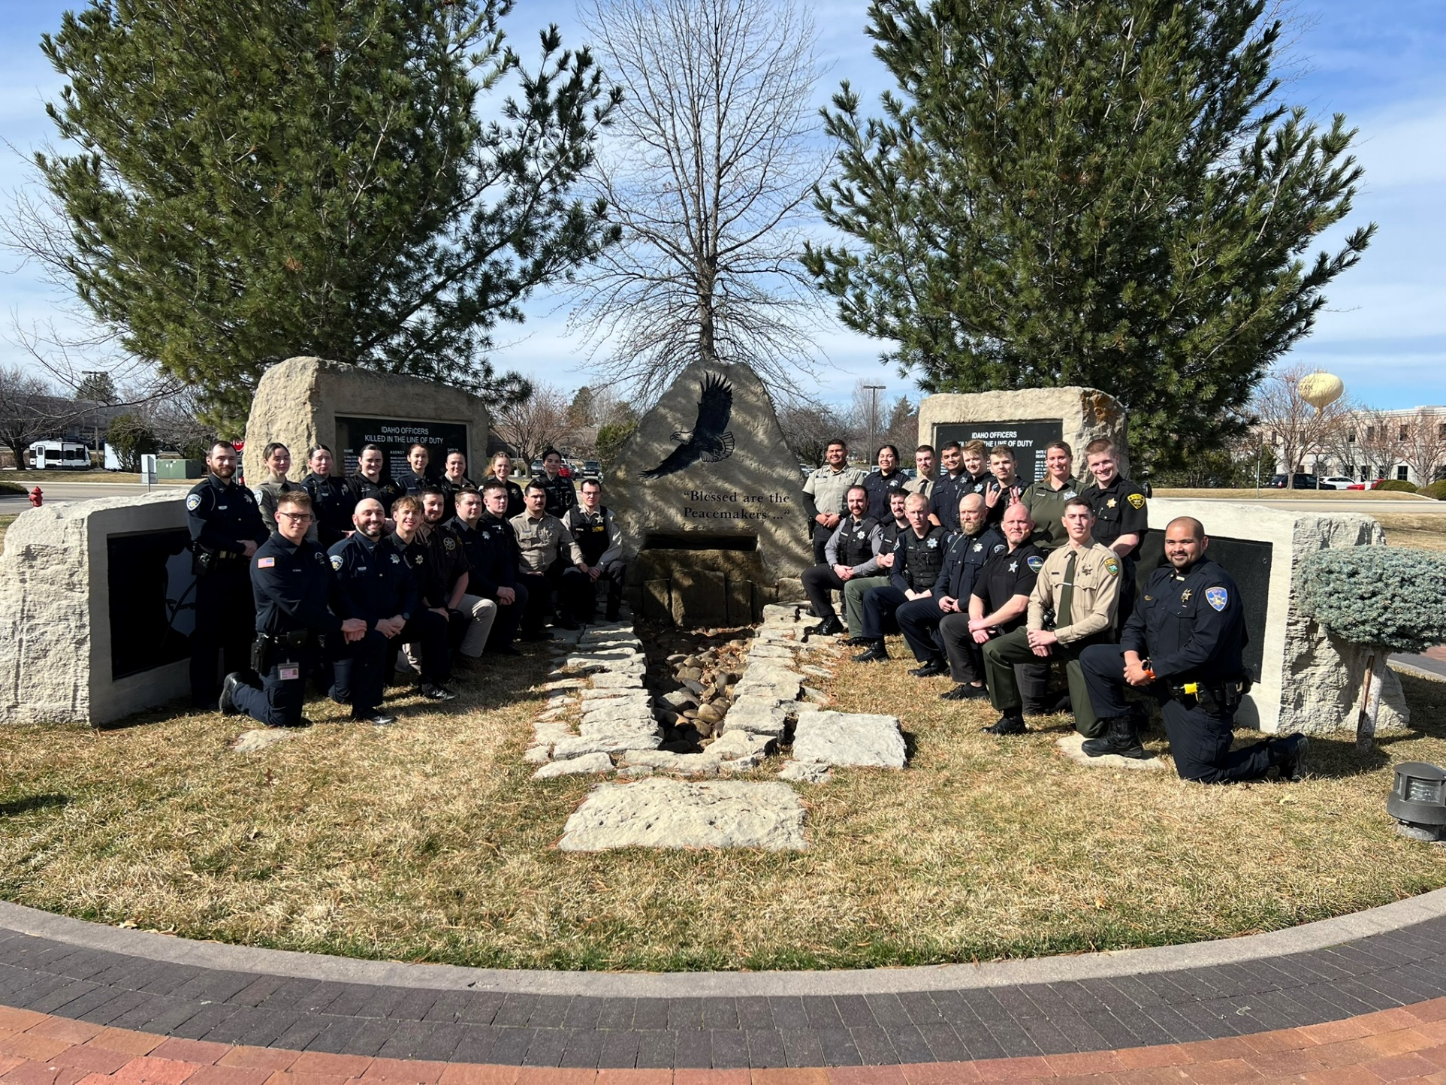

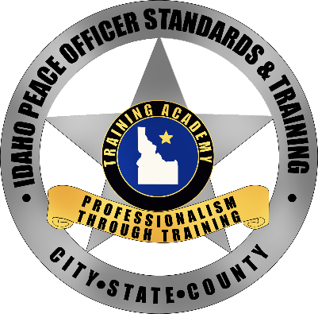



IDAHO PEACE OFFICER STANDARDS AND TRAINING ACADEMY

BASIC DETENTION #97

Graduation

March 14, 2025





Message from the Governor

On behalf of all Idaho citizens, congratulations for graduating from the Idaho Peace Officers Training Academy. I am proud of each one of you. Idaho is fortunate to have such honorable and highly qualified men and women working to protect our citizens.

I want to commend you for choosing to serve and protect the great quality of life we all enjoy. In making this decision, you have chosen a career that will require commitment, courage, and passion in equal measure. I applaud you and your families for your willingness to serve our great state.

I know that each one of you will strive to serve with honor and integrity. Please know that the work of Idaho’s law enforcement officers constitutes one of the truly proper roles of government, and you have my unequivocal support in accomplishing your mission.

Sincerely,

Brad Little  
Governor of Idaho

Class Motto -

“No One Fights Alone”

Program

|  |  |
| --- | --- |
| Entrance & Pledge of Allegiance | IDOC Honor Guard & Detention Academy Class #97 |
| Introduction | Bryan Beverley POST Training Manager  Sean Lethbridge Lead Coordinator |
| Class President Address | Amanda Wampler Blaine County Sheriff’s Office |
| Presentation of Special Awards | Sean Lethbridge POST Training Coordinator |
| Presentation of Graduation Certificates | Sean Lethbridge & Agency Representatives |
| Code of Ethics and Oath Administered | Sheriff Morgan Ballis Blaine County Sheriff’s Office |
| Closing Remarks by Class Vice President | Quenton Bennett Bonneville County Sheriff’s Office |

Special Awards:

*Top Student*

Accumulation of all test scores and evaluations.

To be announced

*Tactical Edge*

Elected by classmates – The most wanted as their backup.

*To be announced*

Officers

|  |  |  |  |  |
| --- | --- | --- | --- | --- |
| John R | Hahn IV | |  | Ada County Sheriff's Office |
| Richard D | Cox | |  | Bannock County Sheriff's Office |
| Stephan S | Gordon II | |  | Bannock County Sheriff's Office |
| Joseph A | Stoesz | |  | Bannock County Sheriff's Office |
| Michael J | Wambach | |  | Bingham County Sheriff's Office |
| Maxwell P | Mihalic | |  | Blaine County Sheriff's Office |
| Amanda L | Wampler | |  | Blaine County Sheriff's Office |
| Quenton M | Bennett | |  | Bonneville County Sheriff's Office |
| Keri A | Dalley | |  | Bonneville County Sheriff's Office |
| Conner P | Loos | |  | Bonneville County Sheriff's Office |
| Mason B | Moffat | |  | Bonneville County Sheriff's Office |
| Douglas H | Wilson II | |  | Boundary County Sheriff's Office |
| Angel C | Carmona | |  | Canyon County Sheriff's Office |
| Alejandra | Guerrero | |  | Canyon County Sheriff's Office |
| Daniel | Sklyarov | |  | Canyon County Sheriff's Office |
| Dakota V | Bybee | |  | Caribou County Sheriff's Office |
| Ambar H | Dominguez Cardena | |  | Cassia County Sheriff's Office |
| Christopher J | Overlin | |  | Cassia County Sheriff’s Office |
| Victor A | Soto | |  | Clearwater County Sheriff's Office |
| Annabel N | Massey | |  | Elmore County Sheriff's Office |
| William S | Berrett | |  | Fremont County Sheriff's Office |
| William W | Irving |  | | Gooding County Sheriff's Office |
| Daniel R | Kaschmitter | |  | Idaho County Sheriff's Office |
| Nevaeh L | Bosques | |  | Jefferson County Sheriff's Office |
| Rylee D | Jepperson | |  | Lemhi County Sheriff's Office |
| Nathan J | Goodrich | |  | Madison County Sheriff's Office |
| Jeremy L | King | |  | Nez Perce County Sheriff's Office |
| Dayton D | Rice | |  | Power County Sheriff's Office |
| Eli G | Van Dyk | |  | Valley County Sheriff's Office |
| Katherine L | Newsome | |  | Washington County Sheriff's Office |
|  |  | |  |  |
|  |  | |  |  |

Idaho Peace Officer Standards and Training  
Code of Ethics

As a member of the law enforcement profession, my fundamental duty is to serve the community; to safeguard lives and property; to protect the innocent against deception, the weak against oppression or intimidation, and the peaceful against violence or disorder; and to respect the Constitutional right s of all to liberty, equality, and justice.

I will keep my private life unsullied as an example to all and will behave in a manner that does not bring discredit to me or to my agency. I will maintain courageous calm in the face of danger, scorn, or ridicule; develop self-restraint; and be constantly mindful of the welfare of others. Honest in thought and deed in both my personal and official life, I will be exemplary in obeying the law and the regulations of my department. Whatever I see or hear of a confidential nature or that is confided to me in my official capacity will be kept ever secret, unless revelation is necessary in the performance of my duty.

I will never act officiously or permit personal feelings, prejudices, political beliefs, aspirations, animosities, or friendships to influence my decisions. With no compromise for crime and the relentless prosecution of criminals, I will enforce the law courteously and appropriately without fear or favor, malice, or ill will, never employing unnecessary force or violence and never accepting gratuities.

I recognize the badge or position of my office as a symbol of public faith, and I accept it as a public trust to be held so long as I am true to the ethics of law enforcement service/public service. I will never engage in acts of corruption or bribery, nor will I condone such acts by other law enforcement or emergency communications officers. I will cooperate with all legally authorized agencies and their representatives in the pursuit of justice.

I know that I alone am responsible for my own standard of professional performance and will take every reasonable opportunity to enhance and improve my level of knowledge and competence.

I will constantly strive to achieve these objectives and ideals, dedicating myself before God, or have a sincere and unfaltering commitment to my chosen profession...law enforcement.

**Director’s Message**

Today we celebrate the achievements of our basic academy graduates as they continue their journey into law enforcement. I congratulate each of you for your personal accomplishment and commitment to our noble profession. While it has been demanding, each of you has risen to the challenge and met the standard to take the oath today as one of Idaho’s finest.

I would like to thank the POST staff, our cadre of outstanding instructors, graders, and role players and specifically the Academy Coordinators who guided these outstanding men and women throughout their many weeks of training. It is through their dedication and tireless efforts that this program is possible as we continue to pursue our Vision: To develop skilled law enforcement professionals who are committed to serving and protecting the people in Idaho.

I would also like to thank the family, friends and colleagues who are here in support of their graduate today. Without your support, these men and women cannot truly be successful whether personally or professionally, so I want to recognize your crucial role in their law enforcement lives.

Thank you for attending today’s ceremony and good luck to all our graduates. We are very proud of you!



Brad Johnson

POST Administrator

It takes a village to host a training academy. Here are the members of our staff and council that make it happen:

[POST Staff](https://post.idaho.gov/contact-us/)

[POST Council](https://post.idaho.gov/council-members/)



Vision Statement:

Ensuring Idaho Law Enforcement professionals model the highest level of integrity and service through excellence in standards and training.

Mission Statement:

Developing skilled law enforcement professionals who are committed to serving and protecting the people of Idaho.