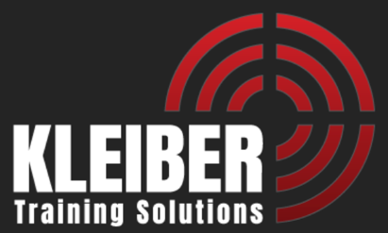
Handgun Red Dot Sight / Patrol Rifle Instructor Inservice Training

June 18-19, 2026
Pocatello, ID

Course Description:
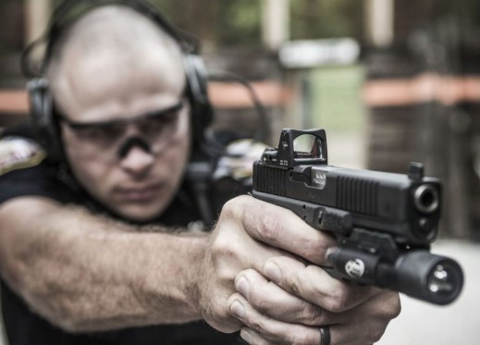
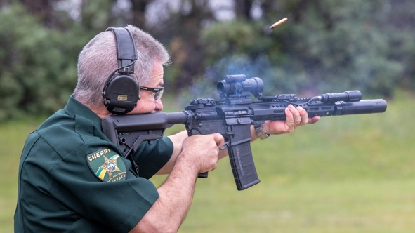
The handgun, red dot sight and patrol rifle 16-hour, in-service training is designed to provide current law enforcement firearms instructors with contemporary strategies on the use of handgun red dot sights and patrol rifles as law enforcement tools. Students will be presented with progressive ideas and given the opportunity to: 1) diagnose shooting errors and making sustainable corrections in other shooters with both handgun red dot sights and patrol rifles; 2) implement stress mitigation techniques to increase correct decision-making skills.
Students also will explore legal and appropriate use of force decisions, stress mitigation techniques to increase correct decision making, use of the handgun red dot sight as a law enforcement tool and progressive methodologies on the patrol rifle.

Prerequisites:
Students must be a current sworn Law Enforcement Officer and completed a basic handgun / firearms instructor certification, and a patrol rifle operator certification.

Students should expect a fast paced and physically active learning environment that will include running, kneeling, and quickly assuming various unique shooting positions

Required Equipment:

Patrol rifle with tactical sling and light 1000 rds rifle ammo

Duty handgun with red dot sight and holster 1000 rds handgun ammo
Hat, electronic ear pro, eye pro Sharpie marker
Laptop (class materials will be provided via Drop Box) Sight tool specific for your rifle and pistol sight
Whistle Shot Timer (optional)

Instructors:
The training staff is comprised of individuals who have a wealth of experience as instructor trainers and utilizing these weapons in real world situations; from police patrol duty and police special weapons teams to military Special Operations conducted in the War on Terrorism, as well as competition shooting.

Dates: June 18-19, 2026

Class will begin on day 1 at 0800

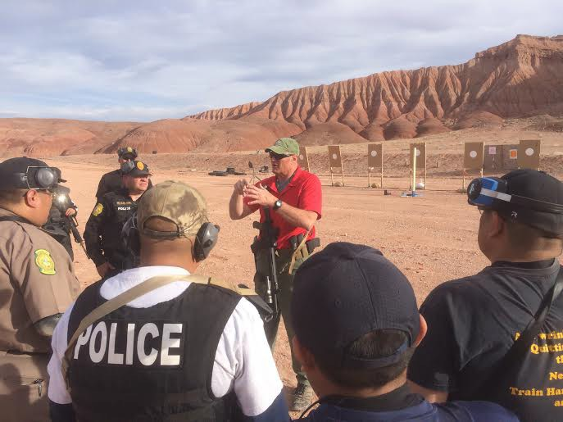
To Register Contact:
Training Coordinator Jene Purman
Pocatello Police Department
(208) 234-6129
Jpurman@pocatello.gov

For More Information Contact:
Dave Kleiber
Kleiber Training Solutions
david.l.kleiber@gmail.com
(970) 846-8588

Range Location:

Equipment Requirements:
The use of rifle compensators or muzzle brakes ARE NOT ALLOWED UNDER ANY CIRCUMSTANCES. Factory A2 or military “birdcage” style flash suppressors, or three or four-prong flash-hiders are permitted. Suppressors are encouraged. Blast forward devices such as the Surefire Warden are approved, but these devices must direct ALL gas forward and in line with the barrel and remain in place throughout the training. Any muzzle device possessing ports, holes, etc. that let gas escape in any direction not directly forward and in line to the barrel will NOT BE ALLOWED under any circumstance. There will be ZERO TOLERANCE for equipment that does not meet this requirement. If you are unsure, then err toward the side of standard military flash suppressors. This requirement is designed to reduce the debris, hearing damage and concussive effect inflicted upon the person to the left and right of you on the firing line. Registering for this class implies that the student understands and will comply with this requirement. Course tuition will NOT be refunded if a student is removed for violating this requirement.

KleiberInvestigations.com 970-846-8588
KTS Carbine Qualification Course

(40 rounds)

Yards Seconds Drill Reps Shots

100 15 Start with Rifle in Condition 2
(electric sights ‘off’ if carried that way) 2 4 (4)
2 shots - any position

75 15 Start at Ready 2 8 (12)
2 shots standing
2 shots kneeling

50 4 2 shots from Ready 2 4 (16)

25 8 Combat Reload 2 6 (22)
(1 shot / reload / 2 shots)

15 4 Start at Ready, move to low profile position
2 shots 2 4 (26)

10 8 Handgun Transition Drill 2 4 (30)
(1 shot carbine / 1 shot handgun)

7 3 Start at Ready 2 6 (36)
2 shots to body / 1 shot to head)

7 to 3 5 Shoot while moving – 4 shots 1 4 (40)

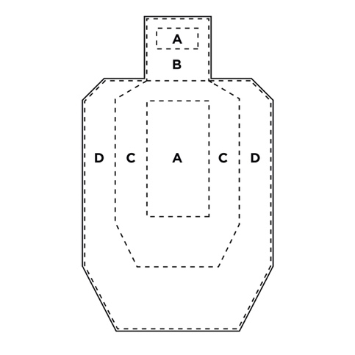
Target: IPSC Silhouette

Scoring :
A Zone (Body) – 5
A Zone (Head) – 5
B Zone (Head) – 1
C Zone (Body) – 4
D Zone (Body) - 1

Maximum Possible Score: 200
90% 180
80% 160 (passing score)

