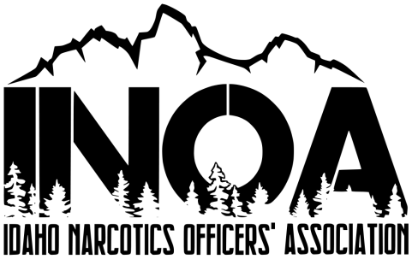
Idaho Narcotics Officers’ Association
Conference & Training
June 29th- July 1st 2026
The Riverside Hotel, 2900 W Chinden BLVD, Boise Idaho
For all Narcotics Officers, Detectives, Patrol Officers, Patrol Supervisor’s, Probation Officers, Prosecutors and others interested in fighting the war against drugs.
Training Topics: Guest Speaker George Christie, Former Hells Angels President, Outlaw Motorcycle gangs, DEA/Cartel Information That You Will NOT Want to Miss

Personal Information (Please type or print – One form per person registering)
Name ____________________________________________________
Agency ____________________________________________________
Address ____________________________________________________
Phone ____________________________________________________
E-Mail ____________________________________________________

Payment Information Return by June 22nd 2026
Registration: Idaho Narcotics Officers’ Association
$425.00 P.O. Box 680
$425.00 Rigby, Idaho 83442
Check / Money Order Enclosed for: $______ Make payable to INOA
Will pay @ door $ 425.00 Contact Detective Pettingill to pay with
Check in begins at 6:00 PM on Sunday June28th, 2026 Credit Card at 208-243-2567
Accommodations Make your reservations prior to June 2nd, 2026
Room Rates: The Riverside Hotel & Convention Center
Single Occupancy $191.00 2900 West Chinden BLVD, Boise Idaho
Phone: 208-343-1871
https://riversideboise.com/
Use code: INOA if register online
For more information Ask for Idaho Narcotics Officer Association for government rate
Contact: Randy Herbert – INOA President randyherb001@gmail.com 208-397-8358
Vince Kaaiakamanu – Vice President vincek@madisonsheriff.com 208-201-2165
Jason Pettingill – Treasurer jpettingill@madisonsheriff.com 208-243-2567
Jamie Claiborn- Secretary inoasecretary@gmail.com

