HOSTED BY: CHUBBUCK POLICE DEPARTMENT AUGUST 5TH-9TH, 2024
CHUBBUCK, ID. 40 HOUR POST CERTIFIED
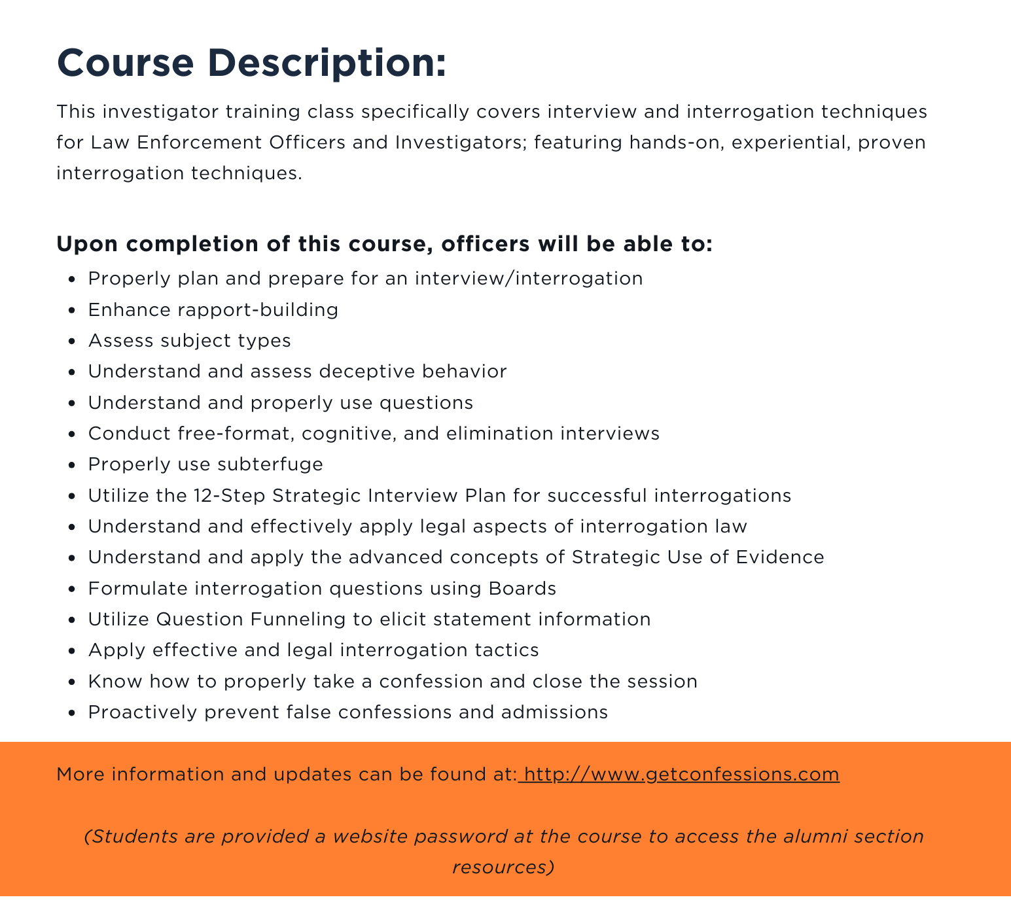
LOCATION: Chubbuck Police Department
5160 Yellowstone Ave. Chubbuck, ID 83202
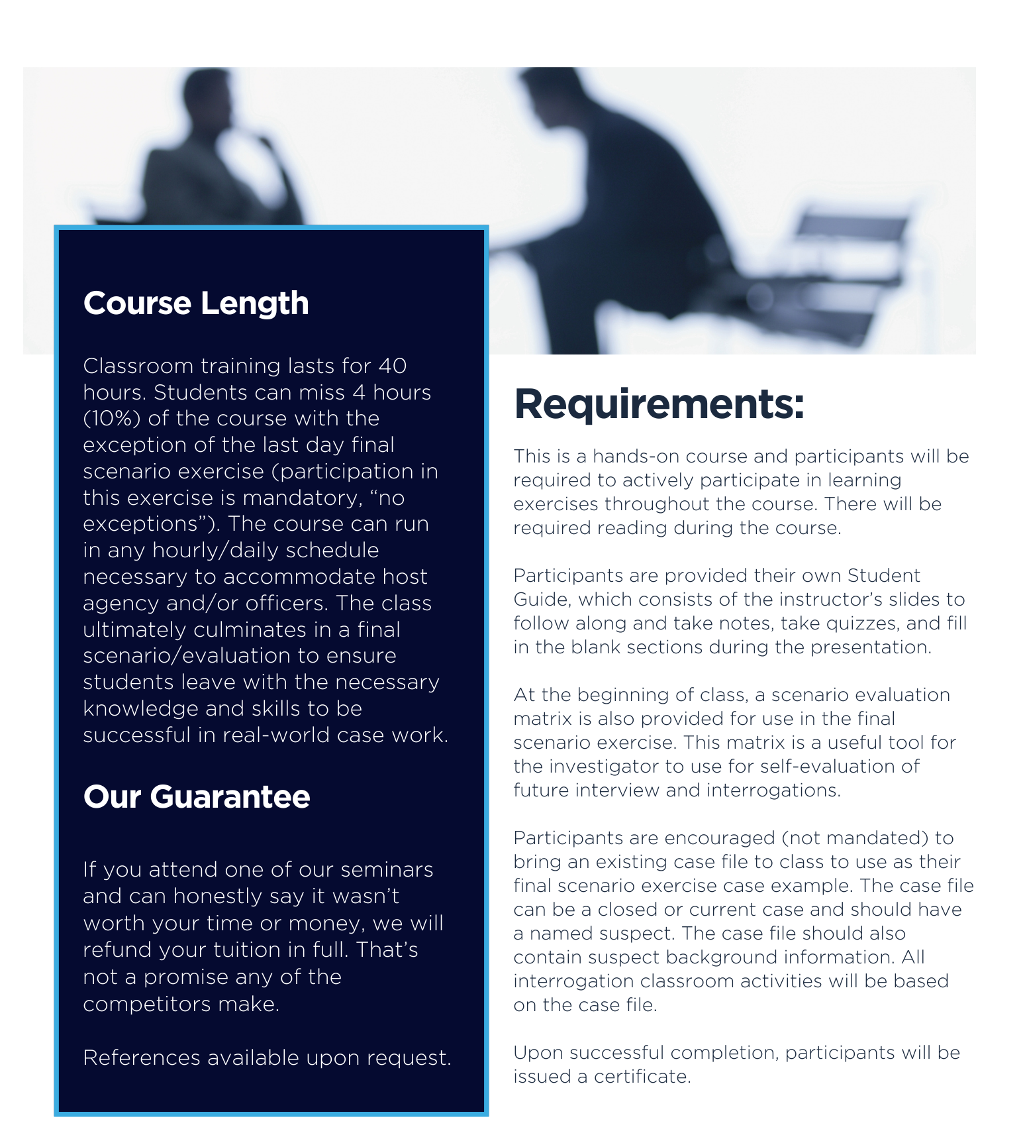
FEES: Tuition is $599 per student with materials and alumni and resource access included. Course 8am to 5pm, Mon.-Fri.

