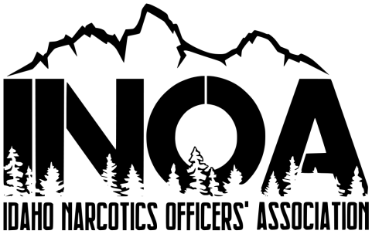
Idaho Narcotics Officers’ Association
Conference & Training
June 3rd thru the 5th 2024
The Riverside Hotel, 2900 W Chinden BLVD, Boise Idaho
For all Narcotics Officers, Detectives, Patrol Officers, Patrol Supervisor’s, Probation Officers, Prosecutors and others interested in fighting the war against drugs.
Training Topics: Human Trafficking, Fentanyl and other Synthetic Opiates

Personal Information (Please type or print – One form per person registering)
Name ____________________________________________________
Agency ____________________________________________________
Address ____________________________________________________
Phone ____________________________________________________
E-Mail ____________________________________________________

Payment Information
Registration: Idaho Narcotics Officers’ Association
$350.00 P.O. Box 680
$350.00 Rigby, Idaho 83442
Check / Money Order Enclosed for: $______ Make payable to INOA
Will pay @ door $ 350.00 Contact Detective Pettingill to pay with
Check in begins at 6:00 PM on Sunday June 2nd 2024 Credit Card at 208-243-2567
Accommodations Make your reservations prior to April 30th
Room Rates: The Riverside Hotel & Convention Center
Single Occupancy $189.00 2900 West Chinden BLVD, Boise Idaho
Phone: 208-343-1871
https://riversideboise.com/
Use code: INOA if register online
For more information Ask for Idaho Narcotics Officer Association for government rate
Contact: Randy Herbert – INOA President randyherb001@gmail.com 208-397-8358
Vince Kaaiakamanu – Vice President vkaaiakamanu@co.fremont.id.us 208-624-4482
Jason Pettingill – Treasurer Jpettingill@co.jefferson.id.us 208-745-9210
Jamie Claiborn- Secretary inoasecretary@gmail.com

