Rangetech.us Sniper Level II Course
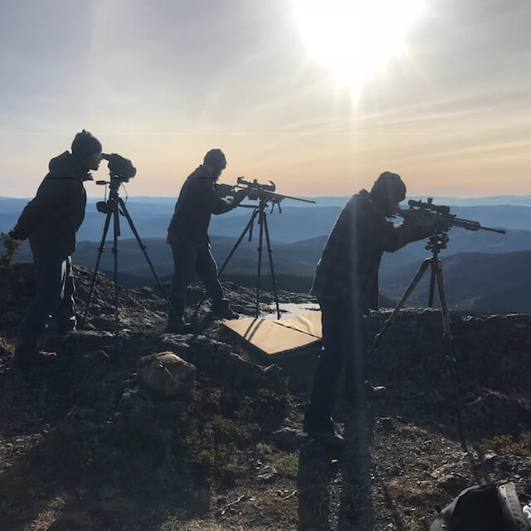
Description: This class is for level 1 certified snipers looking to increase their capabilities and knowledge of marksmanship though understanding their environment and calculating proper shooting solutions for each environment. Students will also be introduced to tri-pod shooting and high angle shots.
Presented By: Rangetech.us
Hosing Agency: Rexburg Police Department
Cost: $350 per person
Location: Rexburg Police Department training center
Dates: May 20 2024 through May 21 2024
Time: 7:30-17:30 daily
Host Contact: Rexburg Police Officer Ryan Kamachi
Contact Information: Cell: (208)201-7378 Email: ryan.kamachi@rexburg.org
Class Availability: 10 spots
Equipment needed
Outdoor all-weather clothing, rifles equipped with high quality first focal plane rifle scope, rifle sling, Hog saddle or Arca Rail and tripod, 200 rounds of ammunition, ballistic solver i.e. Kestrel, hearing protection, eye protection, shooting mats, backpacks, scabbards, spotting scopes or binoculars, 20’ paracord, firearm cleaning kits and solution, toiletries, 4 liters water per day, food for lunch, any sun screen and protective clothing desired.

